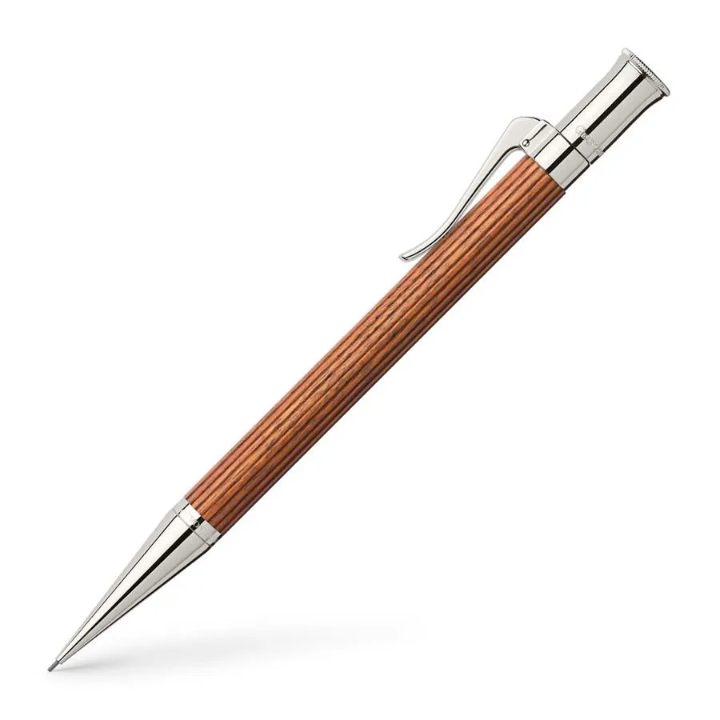

Graf von Faber-Castell

**Propelling pencil Classic Pernambuco**

Productdetails

* Barrel made of Pernambuco wood
* Platinum-plated metal parts
* Solid, spring-loaded clip
* Break resistant lead, 0.7 mm (about 0.03 in), hardness B
* Reservoir for spare leads
* Detachable end cap
* Replaceable white eraser
* Overall dimension: Length 140 mm (about 5.51 in) x Ø 9 mm (about 0.35 in)
* Weight: 40 g
* Elegant, wooden gift box included

**The Classic Pernambuco propelling pencil features a distinctive fluted design and is available in various materials including solid sterling silver and platinum-plated finishes, as well as durable noble woods like ebony, pernambuco, grenadilla, and macassar. Each pen’s unique grain is highlighted by the platinum details, making every piece one-of-a-kind.**